**Game 3: Brains, please!**

**Why?**

Now that we have a firm understanding about how images work, it is time to expand our vision with some “filters” we apply to the scan to look for certain properties. Like instagram and snapchat filters that exaggerate certain aspects of the face, MR “filters”, or contrasts, exaggerate components in the scan like fat or water. Learning about how to control these contrasts can help us see the brain in many lights and identify things that we can’t otherwise.

**Materials**

* Brain specimen tube

**Background:**

1. Key Terms
2. Brain tissue types
3. RF Pulse
4. FA
5. TE
6. TR
7. T1, T2, PD
8. T1w, T2w, PDw
9. Basics

Like any other part of the body, the brain has many types of tissues with different physical properties. When using the MR scanner, we often rely on them to tell apart brain regions and look for areas where these properties change because of diseases. To highlight specific tissues, we can use a T1-weighted, T2-weighted, or PD weighted scan.

1. Explanations

* **Brain tissue types:** There are 3 major types of brain tissues: **Cerebrospinal fluid (CSF)**, **White Matter (WM)**, and **Gray Matter(GM)**. Cerebrospinal fluid is the liquid content of brain ventricles. It flows in and around the brain to absorb impact from injuries to the skull and provide nutrients. White matter effects learning, distribution of action potentials, and communication between different regions of the brain. It’s called white matter because its neuronal axons are covered in a protective fatty sheath which gives it a white color. Gray matter mainly receives incoming information and regulates outgoing information.

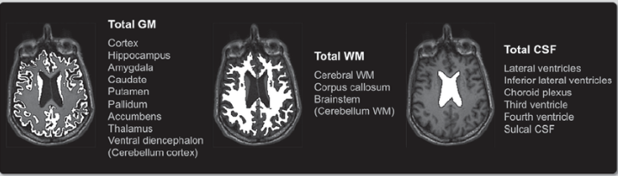



* **RF Pulse**: this is a short-lived magnetic field that tips the protons off their main magnetic field axis so that they are at an angle to it. How much they get tipped depends on the strength and duration of the RF pulse.

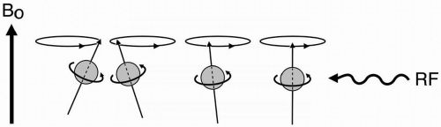



* **Flip Angle (FA)** is the net rotation angle of the magnetization when an RF pulse is applied. A FA value of 0 signifies no change, while a 180 degree FA value signifies a rotation of 180 degrees so the magnetization is pointing straight down. At low flip angles, the MR signal is roughly proportional to the flip angle. This no longer holds at higher flip angles, and the signal dependence on flip angle gets more complicated and depends on the next two MR parameters.
* 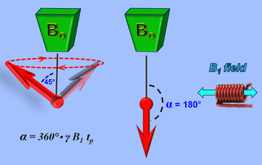
* **Echo Time (TE)** is the time difference between the time when the RF pulse arrives at the target to the time when the signal bounces back and hits a peak, forming what’s called an echo.

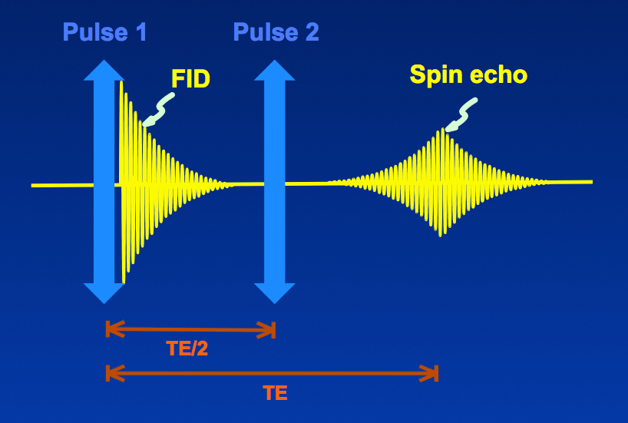



* **Repetition Time (TR)** is the time difference between one set of RF pulses (a 90 degree pulse and an 180 degree pulse in the example below) and the next. It is called “repetition” because we excite the spins in exactly the same way between the two intervals. We need to repeat the excitation because we only have time to get partial information within each TR. Combining signals from multiple TRs gives us a complete image.

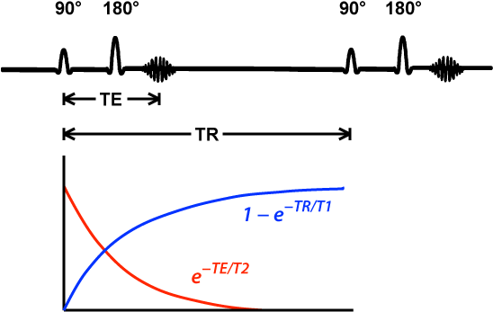



* **Longitudinal Relaxation Time (T1)**, **Transverse Relaxation Time (T2)**, and **Proton Density (PD)** are the main physical properties measured by MRI.
* T1 and T2 have units of seconds or milliseconds and decide how fast signals “relax” back into their equilibrium value.
* PD refers to the relative density of protons, so it measures how much signal we can get from the same volume of tissue. All other things being equal, the higher a tissue’s PD is, the brighter it looks on the image.

The table below shows typical T1, T2, and PD values for the three brain tissue types at a main field strength of 1.5 Tesla.



|  | **GM** | **WM** | **CSF** |
| --- | --- | --- | --- |
| **T1 (ms)** | 1130 | 750 | 1940 |
| **T2 (ms)** | 119 | 87 | 230 |
| **PD (relative)** | 1.04 | 0.95 | 1.02 |

<https://campar.in.tum.de/pub/buonincontri2018ismrmrep/buonincontri2018ismrmrep.pdf>

Table 1: Typical brain tissue parameter values at 1.5T

* **T1-, T2-, and PD-weighted (T1w, T2w, PDw)**: You can think of these as 3 “filters” for MR images. In general, T1w highlights tissues with short T1, T2w highlights tissues with long T2, and PDw highlights tissues with high PD.
* T1w is known for highlighting fat, proteins, melanin, and areas of breakdown in the blood-brain barrier, indicating inflammation.
* T2w highlights liquids such as CSF in the brain and detects deoxygenated hemoglobin, methemoglobin(a type of hemoglobin that can’t give out oxygen to tissues), or hemosiderin (caused by blood leaking out of capillaries) in lesions and tissues.
* PDw highlights tissues with high concentration of protons and can be used to assess joints: it offers distinct contrast between fluid, cartilage, and bone

| **Contrast** | **TE** | **TR** |
| --- | --- | --- |
| T1w | Short | Medium |
| T2w | Medium | Long |
| PDw | Short | Long |

Table 2: How to set TE and TR to get different contrasts

**Lab procedures**

1. Insert the brain specimen tube and perform scanner calibration.
2. Start off with Panel 1. There are three imaging options present: T1-weighted, T2-weighted, and PD-weighted. Select each of the options and click run to acquire an image . How are the scans different from each other? Note down below on relative signal strengths and what each of the scans highlights.

| **Weighting Calibration** | **Tissue with highest Signal** | **Tissue with medium Signal** | **Tissue with lowest Signal** | **What does the scan highlight?** |
| --- | --- | --- | --- | --- |
| T1 Weighted |  |  |  |  |
| T2 Weighted |  |  |  |  |
| PD Weighted |  |  |  |  |

Answer the question at the bottom of the panel to continue.

1. After you correctly answer the question on Panel 1, you will be prompted to continue to Panel 2. Here you will adjust TR, TE, and FA values to observe how the scan changes. Also observe how certain TR and TE values produce the same results as T1 and T2 weighted scans. Pick 5 sets of TR, TE, and FA values to fill out the table below.

|  | **TR (ms)** | **TE (ms)** | **FA (deg)** | **Observations** |
| --- | --- | --- | --- | --- |
| Set 1 |  |  |  |  |
| Set 2 |  |  |  |  |
| Set 3 |  |  |  |  |
| Set 4 |  |  |  |  |
| Set 5 |  |  |  |  |

Describe what you see as you change each of the following parameter while fixing the other two:

* TR value:
  + As you increase this value, is the contrast increasing or decreasing?
    - Ans:
  + How does contrast change when the TR value is large and the TE value is short?
    - Ans:
* TE value:
  + As you increase this value, is the contrast increasing or decreasing?
  + How does contrast change when the TR value is short and the TE value is large?
* FA value:
  + What do you notice when the FA value gets larger?
  + How does the signal dependence on FA change as you increase TR?

Answer the question at the bottom of the panel to continue.

1. After you correctly answer the question on Panel 2, you will be prompted to continue to Panel 3, revealing a graph with signal strengths for CSF, WM, and GM. How can you use this graph to produce different contrasts? Fill out the table below based on what you learned earlier in the lesson.

|  | **TR (ms)** | **TE (ms)** | **FA (deg)** | **Goal** |
| --- | --- | --- | --- | --- |
| Set 1 |  |  |  | High signal in CSF and low in GM |
| Set 2 |  |  |  | Very little contrast between GM and WM |
| Set 3 |  |  |  | GM > WM > CSF |

**Questions**

1. Which set of parameters gives you the most T1 weighted scan?
   1. TR = 4 s, TE = 2 ms
   2. TR = 5 s, TE = 500 ms
   3. TR = 900 ms, TE = 5 ms
   4. TR = 800 ms, TE = 500 ms
2. What does this PD weighted scan highlight?

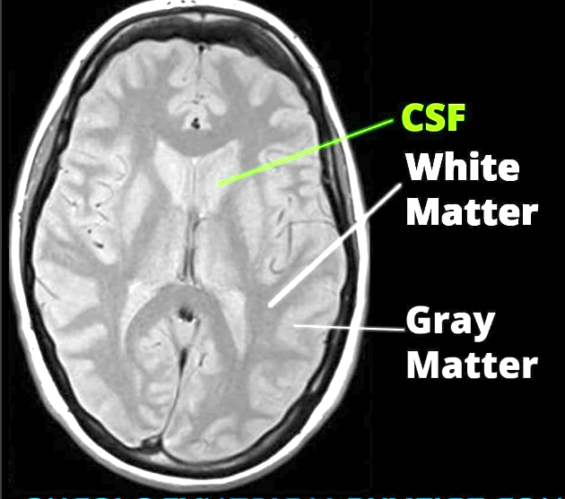



* 1. It highlights tissues with the highest density of protons
  2. It highlights tissues with the lowest density of protons
  3. It highlights tissues only at a specific density that the imager can specify
  4. It highlights tissues with no protons at all

1. How would substances with small T2 values appear on a T2-weighted scan?
   1. It would appear bright
   2. It would appear dark
   3. It would appear larger than its physical size
   4. It would appear smaller than its physical size
2. What is a T1 weighted image useful for?
   1. Assess the relative densities of brain tissues
   2. Detecting breakdown in the blood-brain barrier
   3. Detecting deoxygenated hemoglobin
   4. Visualizing the ankle joint
3. Based on Table 1, predict what tissue type (GM/WM) will be highlighted with each filter or MR contrast. Circle the correct tissue type for each contrast:
   1. T1w: GM WM
   2. T2w: GM WM
   3. PDw: GM WM